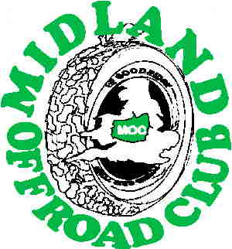
4 X 4 Off Road Challenge Event
Held by Midland Offroad Club.
at ______________________
On Saturday _____________ 2004.
Membership No. |  |  |  | Class, Std / Mod
Drivers name |  |  |  |  | Co-drivers name,
Date of birth, |  |  |  |  | Date of birth.
Address, |  |  |  |  | Address,
Post code, |  |  |  |  | Post code,
Phone no., |  |  |  |  | Phone no.,
Please note that the following questions could save your life in rare event of an
Accident. Ignore them at your own risk………
Next of kin, Tel. No., |  |  |  |  | Next of kin, Tel. No
Your Blood group, |  |  |  |  | Your blood group,
Any allergies, |  |  |  |  | Any allergies,
Any regular medication, |  |  |  |  | Any regular medication,
Vehicle type, |  |  |  |  | Reg. No.,
Colour, |  |  |  |  | Roll over protection fitted,

We the undersigned understand that motor sport events can be dangerous. We also understand that the majority of this Challenge Event is not speed orientated & therefore agree to drive accordingly.
We agree to put safety considerations first in all aspects and disciplines of the Event and to abide by all Marshals and Officials decisions. In signing below we agree to act in a responsible manner and to absolve the Land Owner, the Organisers listed above, & any other officials acting on their behalf from any liability arising through loss, injury or damage caused to Ourselves or any third parties during this event, and agree to adhere to the following rules at all times: - * only vehicles fitted with a roll or cage will be allowed to attempt the extreme "ultra markers"*, * a brightly coloured sail must be used on all winch cables inc. nylon ropes at all times,* * a wide strop must be used to when winching from trees*, *seat belts must be worn by all vehicle occupants* , Please note that this is an uninsured, fun event & run on a non profit making basis.
Drivers signature, | Co-drivers signature,
Date, | Date,

Entries to:- MOC 13 Woodland Ave, Burbage, Hinckley. LE10 2BD

