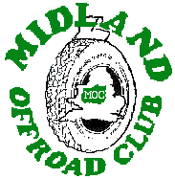
Wanted
13 – 16 Year Old Off Road Drivers

If you are:-
A) Between the ages of 13 and 16
B) Interested in cars (preferably Off Road)

C) Would like to get involved in competition
D) And live in the Midlands Area

Then contact me right now!

4X4 Trialing is acknowledged as the best way to start in OffRoading, teaching you all the major skill’s needed to move on into other disciplines later, both on and off road. Like Car Control – Observations – Anticipation – and reading the ground.

You will obviously need an understanding and co-operative parent, willing to fund your endeavors, help with work on your car, and tow your car to and from events.

For further info call Bruce on 01455 890580 – 07713 249845

or niva-maxi@freeuk.co.uk

